k|]; lj1KtL
- d'lQmgfy ljsf; a}+s4f/f :6f{6 ck / gofF pBdLx? s]Gb«Lt ljQLo ;fIf/tf sfo{qmd cfof]hgf

ldlt @)*@÷)!÷@#
d'lQmgfy ljsf; a}+sn] ;fdflhs pQ/bfloTj sfo{qmd cGtu{t :6f{6 ck / gofF pBdLx? s]Gb«Lt ljz]if ljQLo ;fIf/tfd"ns sfo{qmd cfof]hgf u/]sf] 5 . sfo{qmdsf] pb]Zo pBdLx?nfO{ ljQLo Joj:yfkg, a}+lsË ;]jfsf] kx'Fr, Joj;flos of]hgf tof/L, ahf/ Joj:yfkgsf /0fgLlt to ug]{, JolQmut ah]6, gub k|jfx, shf{ kl/rfng tyf u|fxssf] clwsf/ nufotsf ljifo a:t'x?df ;fIf/ u/fpg' lyof] .
o; sfo{qmddf @^ hgf :6f{6ck tyf o'jf pBdLx?sf] pT;fxhgs ;xefuLtf /x]sf] lyof] . o; sfo{qmddfkm{t pBdLx?nfO{ ljQLo 1fgsf] k|of]u u/]/ Jofkf/, Joj;fonfO{ cem lbuf] agfpg] dfu{bz{g ldNg] a}+ssf] ljZjf; 5 . g]kfnL o'jfx?nfO{ ;zQm agfO{ a}+sn] ;fdflhs pQ/bfloTj cfTd;fy u/]sf] a}+ssf] wf/0ff /x]sf] 5 .
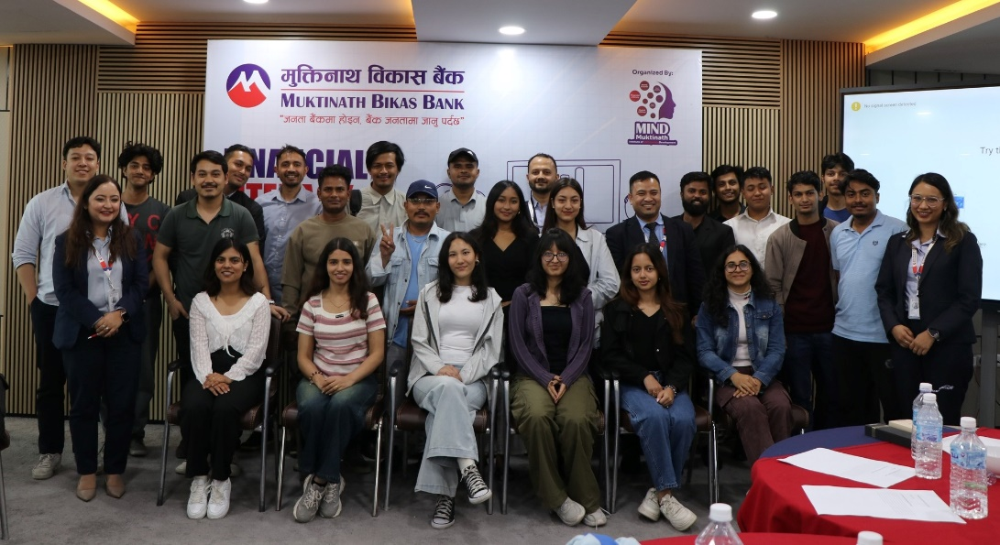
a}+sn] xfn} df]jfO{n Ps kmfObf cg]s lng ;Sg] d'lQmgfy kmfObf Pk ;+rfngdf NofPsf] 5 . To;} u/L df]afO{n a}+lsË, So"cf/ sf]8 :Sofg, cgnfO{g shf{ cfj]bg, cgnfO{g vftf vf]Ng], O{G6/g]6 a}+lsË, vftf d} /]ld6\ofG; hDdf cflb h:tf sfo{x? a}+ssf] zfvfdf pkl:yt geO{ 3/af6 ug{ ;lsg] Joj:yf ul/Psf] 5 .

k|d'v ;"rgf clwsf/L
>L ltn axfb'/ u'?Ë

